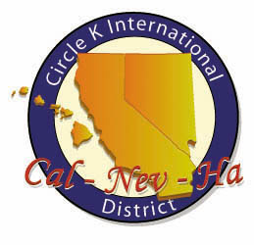
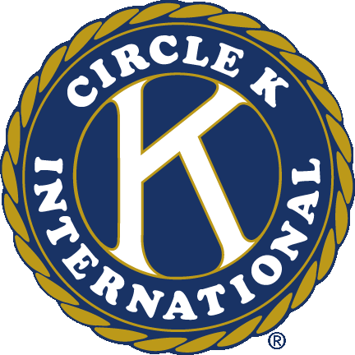
Circle K International
Mt. San Antonio College
First General Meeting
Wednesday, Sept. 26, 2012

- Call to Order: __________
Circle K Pledge
I pledge to uphold the objects of Circle K International. To foster compassion and goodwill toward others through service and leadership, to develop my abilities and the abilities of all people, and to dedicate myself to the realization of mankind's potential.

- Introduction of Special Guests
- What is Circle K?
- Introduction of Board
- Icebreaker
- Upcoming Events
  - LA County Fair Social
    - When: Thursday, Sept. 27 @ 6pm – closing
    - Where: 1101 West McKinley Avenue, Pomona, CA 91768
    - What: Come join us in our first fall social! Free admission to all Mt. SAC students! Just remember to bring your IDs!
    - Rides can be provided
  - September DCM
    - When: Saturday, Sept. 29, @ 11am – 1pm
    - Where: Pasadena City College, Crevling Lounge (1570 E. Colorado Blvd. Pasadena, CA 91106)
    - What: Come get to know the rest of the division and learn more about the inner workings of Circle K! After the DCM, there will be free lunch and Kickball Tournament!
- Ongoing Service Events
  - Canned Food Drive (donated to Walnut Food Bank)
  - Clothing Drive (donated to Shepherd’s Pantry)
  - Book Drive (donated to Better World Books)
- Appointed Board Applications
  - Open positions:
    - Historian,
    - Fundraising Chair
    - Service Chair
    - Technology Chair
  - More information can be found at mtsaccirlek.weebly.com/apply
  - Applications can be found at mtsaccirclek.weebly.com/applications
  - Applications are due on Friday, Oct. 12 @ 11:59pm
- Raffle
- Adjournment: __________

Questions? Comments? Concerns?
Contact us at mtsac.circlekinternational@gmail.com
Like our Facebook page! www.facebook.com/Mt-SAC-Circle-K-International
Check out our new website! www.mtsaccirclek.weebly.com
Circle K International
Mt. San Antonio College
First General Meeting
Wednesday, Sept. 26, 2012

- Call to Order: __________
Circle K Pledge
I pledge to uphold the objects of Circle K International. To foster compassion and goodwill toward others through service and leadership, to develop my abilities and the abilities of all people, and to dedicate myself to the realization of mankind's potential.

- Introduction of Special Guests
- What is Circle K?
- Introduction of Board
- Icebreaker
- Upcoming Events
  - LA County Fair Social
    - When: Thursday, Sept. 27 @ 6pm – closing
    - Where: 1101 West McKinley Avenue, Pomona, CA 91768
    - What: Come join us in our first fall social! Free admission to all Mt. SAC students! Just remember to bring your IDs!
    - Rides can be provided
  - September DCM
    - When: Saturday, Sept. 29, @ 11am – 1pm
    - Where: Pasadena City College, Crevling Lounge (1570 E. Colorado Blvd. Pasadena, CA 91106)
    - What: Come get to know the rest of the division and learn more about the inner workings of Circle K! After the DCM, there will be free lunch and Kickball Tournament!
- Ongoing Service Events
  - Canned Food Drive (donated to Walnut Food Bank)
  - Clothing Drive (donated to Shepherd’s Pantry)
  - Book Drive (donated to Better World Books)
- Appointed Board Applications
  - Open positions:
    - Historian,
    - Fundraising Chair
    - Service Chair
    - Technology Chair
  - More information can be found at mtsaccirlek.weebly.com/apply
  - Applications can be found at mtsaccirclek.weebly.com/applications
  - Applications are due on Friday, Oct. 12 @ 11:59pm
- Raffle
- Adjournment: __________

Questions? Comments? Concerns?
Contact us at mtsac.circlekinternational@gmail.com
Like our Facebook page! www.facebook.com/Mt-SAC-Circle-K-International
Check out our new website! www.mtsaccirclek.weebly.com

