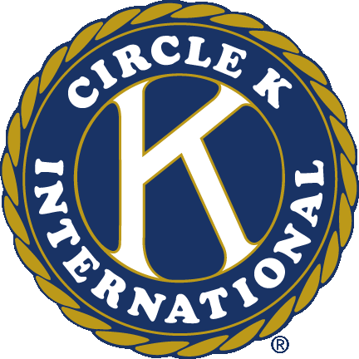
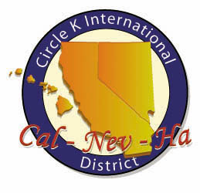
Circle K International
Mt. San Antonio College
First General Meeting
Wednesday, Sept. 26, 2012

- Call to Order: __________
Circle K Pledge
I pledge to uphold the objects of Circle K International. To foster compassion and goodwill toward others through service and leadership, to develop my abilities and the abilities of all people, and to dedicate myself to the realization of mankind's potential.

- Introduction of Special Guests
- Happy/Sad Change
- Past Events
  - September DCM
  - Ability First: Festival of Fall
- Upcoming Events
  - Rosemary Children's Services: Golf Tournament
    - When: Thursday, Oct. 4th 9am-5pm
    - Where: 6300 Country Club Drive La Verne, CA 91750
    - What: Come out and help run Rosemary Children’s Services fundraiser Tee off for Teens. Keep in mind that we will be at a country club, so please don’t wear sandals, jeans, or t-shirts.
  - Habitat Restoration
    - When: Saturday, Oct. 6th 9am – 12pm
    - Where: Peck Park, Arcadia
    - What: Come out and help beautify Peck Park with CalPoly Pomona! Keep in mind that we will be working in the dirt so please wear comfortable clothes and shoes that you don’t mind dirtying!
  - AIDS Walk
    - When: Sunday, Oct. 14th 8am – 1pm
    - Where: West Hollywood
    - What: Come out and help raise money to find a cure for AIDS, as well as fund programs The walk is approximately 6.2 miles, and will begin and end in West Hollywood.
  - CKI South
    - When: Sunday, Oct. 21
    - Where: Stanton Park, Stanton (11111 Cedar St. Stanton, CA 90680)
    - What: Come out to the first district event of the fall! Meet new people from the southern half Cal-Nev-Ha and donate to PTP! October DCM will also be held there.
- Ongoing Service Events
  - Canned Food Drive (donated to Walnut Food Bank)
  - Clothing Drive (donated to Shepherd’s Pantry)
  - Book Drive (donated to Better World Books)
- Theme
- Appointed Board Applications
  - Open positions: Historian, Fundraising Chair, Service Chair, Technology Chair
  - Applications can be found at mtsaccirclek.weebly.com/applications
  - Applications are due on Friday, Oct. 12 @ 11:59pm
- Adjournment: __________
Questions? Comments? Concerns?
Contact us at mtsac.circlekinternational@gmail.com
Like our Facebook page! www.facebook.com/Mt-SAC-Circle-K-International
Check out our new website! www.mtsaccirclek.weebly.com
Circle K International
Mt. San Antonio College
First General Meeting
Wednesday, Sept. 26, 2012

- Call to Order: __________
Circle K Pledge
I pledge to uphold the objects of Circle K International. To foster compassion and goodwill toward others through service and leadership, to develop my abilities and the abilities of all people, and to dedicate myself to the realization of mankind's potential.

- Introduction of Special Guests
- Happy/Sad Change
- Past Events
  - September DCM
  - Ability First: Festival of Fall
- Upcoming Events
  - Rosemary Children's Services: Golf Tournament
    - When: Thursday, Oct. 4th 9am-5pm
    - Where: 6300 Country Club Drive La Verne, CA 91750
    - What: Come out and help run Rosemary Children’s Services fundraiser Tee off for Teens. Keep in mind that we will be at a country club, so please don’t wear sandals, jeans, or t-shirts.
  - Habitat Restoration
    - When: Saturday, Oct. 6th 9am – 12pm
    - Where: Peck Park, Arcadia
    - What: Come out and help beautify Peck Park with CalPoly Pomona! Keep in mind that we will be working in the dirt so please wear comfortable clothes and shoes that you don’t mind dirtying!
  - AIDS Walk
    - When: Sunday, Oct. 14th 8am – 1pm
    - Where: West Hollywood
    - What: Come out and help raise money to find a cure for AIDS, as well as fund programs The walk is approximately 6.2 miles, and will begin and end in West Hollywood.
  - CKI South
    - When: Sunday, Oct. 21
    - Where: Stanton Park, Stanton (11111 Cedar St. Stanton, CA 90680)
    - What: Come out to the first district event of the fall! Meet new people from the southern half Cal-Nev-Ha and donate to PTP! October DCM will also be held there.
- Ongoing Service Events
  - Canned Food Drive (donated to Walnut Food Bank)
  - Clothing Drive (donated to Shepherd’s Pantry)
  - Book Drive (donated to Better World Books)
- Theme
- Appointed Board Applications
  - Open positions: Historian, Fundraising Chair, Service Chair, Technology Chair
  - Applications can be found at mtsaccirclek.weebly.com/applications
  - Applications are due on Friday, Oct. 12 @ 11:59pm
- Adjournment: __________
Questions? Comments? Concerns?
Contact us at mtsac.circlekinternational@gmail.com
Like our Facebook page! www.facebook.com/Mt-SAC-Circle-K-International
Check out our new website! www.mtsaccirclek.weebly.com

