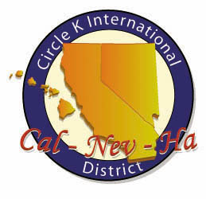
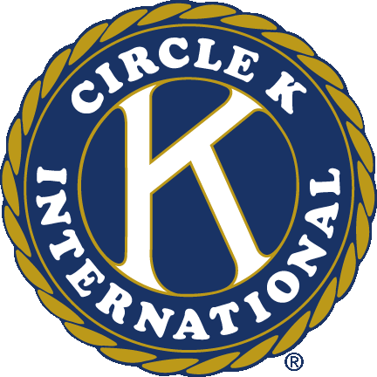
Circle K International
Mt. San Antonio College
Sixth General Meeting
Wednesday, Oct. 31, 2012

- Call to Order: __________
Circle K Pledge
I pledge to uphold the objects of Circle K International. To foster compassion and goodwill toward others through service and leadership, to develop my abilities and the abilities of all people, and to dedicate myself to the realization of mankind's potential.

- Introduction of Special Guests
- Icebreaker
- Past Events
  - Campus Cleanup
  - Fall Training Conference
- Upcoming Events
  - Stop Human Trafficking Conference
    - When: Saturday, Nov. 10 9:00am-10:00am
    - Where: Mt. San Antonio College
    - What: Come learn about human trafficking Saturday afternoon. This relates to one of our District Fundraising Initiatives, Not For Sale. See what you can do to make a difference in ending modern-day slavery.
  - Masquerade Ball
    - When: Saturday, Nov. 10 11:00pm-4:00pm
    - Where: Inspiration Hornblower (1800 North Harbor Drive, San Diego, California 92101)
    - What: Party at San Diego in a three decker boat! For only 30 dollars, you’ll enjoy a sail around the harbor, a dance, casino games, karaoke, and more – all with a ton of other Circle K people! Proceeds go towards PTP!
- Carpools always meet at the roundabout in front of the math and science buildings
- Ongoing Service Events
- Canned Food Drive (Pomona Food Center)  - Clothing Drive (Shepherd’s Pantry) | - Book Drive (Better World Books)  - Soda Tabs (Ronald McDonald House)
- Membership Dues
  - $15 are to be turned in to Robert Agosto
- Happy/Sad Change
- Adjournment: __________
Questions? Comments? Concerns?
Contact us at mtsac.circlekinternational@gmail.com
Like our Facebook page! www.facebook.com/Mt-SAC-Circle-K-International
Join our Facebook group! http://bit.ly/mtsaccki
Check out our website! www.mtsaccirclek.weebly.com

