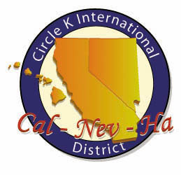
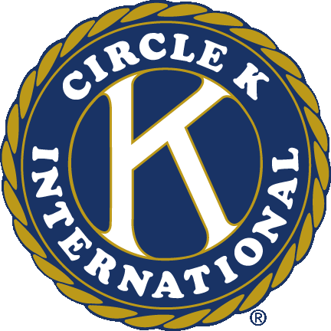
Circle K International
Mt. San Antonio College
Seventh General Meeting
Wednesday, Nov. 7, 2012

- Call to Order: __________
Circle K Pledge
I pledge to uphold the objects of Circle K International. To foster compassion and goodwill toward others through service and leadership, to develop my abilities and the abilities of all people, and to dedicate myself to the realization of mankind's potential.

- Introduction of Special Guests
- Icebreaker
- Past Events
  - Campus Cleanup
  - Fall Training Conference
- Upcoming Events
  - Stop Human Trafficking Conference
    - When: Saturday, Nov. 10 9:00am-10:00am
    - Where: Mt. San Antonio College
    - What: Come learn about human trafficking Saturday afternoon. This relates to one of our District Fundraising Initiatives, Not For Sale. See what you can do to make a difference in ending modern-day slavery.
  - CKI 101
    - When: Saturday, Nov. 10 11:00pm-3:00pm
    - Where: Mt. SAC, Honors Room
    - What: Come learn what Circle K is all about this Saturday! After the 101, we’ll be watching movies while writing holiday cards for the troops overseas.
  - CSU LA Dodgeball Tournament
    - When: Sunday, Nov. 11 12:00pm-5:00pm
    - Where: CSU Los Angeles (5151 State University Drive, Los Angeles, CA 90032)
    - What: Come support our fellow school CSU Los Angeles in their dodgeball fundraiser! It’s only $5 to play, and it’s Halloween themed so you get to wear your costumes!
  - November DCM
    - When: Saturday, Nov. 17 11:00pm-4:00pm
    - Where: Cathedral High School
    - What: It’s that time of the month again. Come out and meet members from other schools in the division! You’ll get updates from the division and participate in a service project!
  - Turkey Trot
    - When: Sunday, Nov. 18 6:00am-10:00am
    - Where: Puente Hills Mall
    - What: Come help out San Gabriel Valley YMCA in their annual Turkey Trot event. Our duties include selling raffle tickets, directing traffic, giving out tshirts, working booths and handling registration, and handing out water bottles
  - Isaiah’s Rock Thanksgiving Packing
    - When: Tuesday, Nov. 20 6:00pm-9:00pm
    - Where: Chino (4450 Edison Ave, Chino 91710)
    - What: Come help out Isaiah’s Rock in their Thanksgiving event! We’ll be packing up food to give out to families with our local Key Clubs and Kiwanis!
- Carpools always meet at the roundabout in front of the math and science buildings
- Ongoing Service Events
- Canned Food Drive (Pomona Food Center)  - Clothing Drive (Shepherd’s Pantry) | - Book Drive (Better World Books)  - Soda Tabs (Ronald McDonald House)
- Membership Dues
  - $15 are to be turned in to Robert Agosto
- Happy/Sad Change
- Adjournment: __________
Questions? Comments? Concerns?
Contact us at mtsac.circlekinternational@gmail.com
Like our Facebook page! www.facebook.com/Mt-SAC-Circle-K-International
Join our Facebook group! http://bit.ly/mtsaccki
Check out our website! www.mtsaccirclek.weebly.com
Circle K International
Mt. San Antonio College
Seventh General Meeting
Wednesday, Nov. 7, 2012

- Call to Order: __________
Circle K Pledge
I pledge to uphold the objects of Circle K International. To foster compassion and goodwill toward others through service and leadership, to develop my abilities and the abilities of all people, and to dedicate myself to the realization of mankind's potential.

- Introduction of Special Guests
- Icebreaker
- Past Events
  - Campus Cleanup
  - Fall Training Conference
- Upcoming Events
  - Stop Human Trafficking Conference
    - When: Saturday, Nov. 10 9:00am-10:00am
    - Where: Mt. San Antonio College
    - What: Come learn about human trafficking Saturday afternoon. This relates to one of our District Fundraising Initiatives, Not For Sale. See what you can do to make a difference in ending modern-day slavery.
  - CKI 101
    - When: Saturday, Nov. 10 11:00pm-3:00pm
    - Where: Mt. SAC, Honors Room
    - What: Come learn what Circle K is all about this Saturday! After the 101, we’ll be watching movies while writing holiday cards for the troops overseas.
  - CSU LA Dodgeball Tournament
    - When: Sunday, Nov. 11 12:00pm-5:00pm
    - Where: CSU Los Angeles (5151 State University Drive, Los Angeles, CA 90032)
    - What: Come support our fellow school CSU Los Angeles in their dodgeball fundraiser! It’s only $5 to play, and it’s Halloween themed so you get to wear your costumes!
  - November DCM
    - When: Saturday, Nov. 17 11:00pm-4:00pm
    - Where: Cathedral High School
    - What: It’s that time of the month again. Come out and meet members from other schools in the division! You’ll get updates from the division and participate in a service project!
  - Turkey Trot
    - When: Sunday, Nov. 18 6:00am-10:00am
    - Where: Puente Hills Mall
    - What: Come help out San Gabriel Valley YMCA in their annual Turkey Trot event. Our duties include selling raffle tickets, directing traffic, giving out tshirts, working booths and handling registration, and handing out water bottles
  - Isaiah’s Rock Thanksgiving Packing
    - When: Tuesday, Nov. 20 6:00pm-9:00pm
    - Where: Chino (4450 Edison Ave, Chino 91710)
    - What: Come help out Isaiah’s Rock in their Thanksgiving event! We’ll be packing up food to give out to families with our local Key Clubs and Kiwanis!
- Carpools always meet at the roundabout in front of the math and science buildings
- Ongoing Service Events
- Canned Food Drive (Pomona Food Center)  - Clothing Drive (Shepherd’s Pantry) | - Book Drive (Better World Books)  - Soda Tabs (Ronald McDonald House)
- Membership Dues
  - $15 are to be turned in to Robert Agosto
- Happy/Sad Change
- Adjournment: __________
Questions? Comments? Concerns?
Contact us at mtsac.circlekinternational@gmail.com
Like our Facebook page! www.facebook.com/Mt-SAC-Circle-K-International
Join our Facebook group! http://bit.ly/mtsaccki
Check out our website! www.mtsaccirclek.weebly.com

